
Introduction To AI
Submitted By : Shamama Syed
Submitted To: Sir Irshad Ullah
Registration No: 24JZELE0563
Section: Ai
Semester: 3RD

Assignment 03:
1)Load both CSVs.
2)Store loads and prices into lists.
write a function to compute.
  - Hourly bill
  - Total bill

Program:

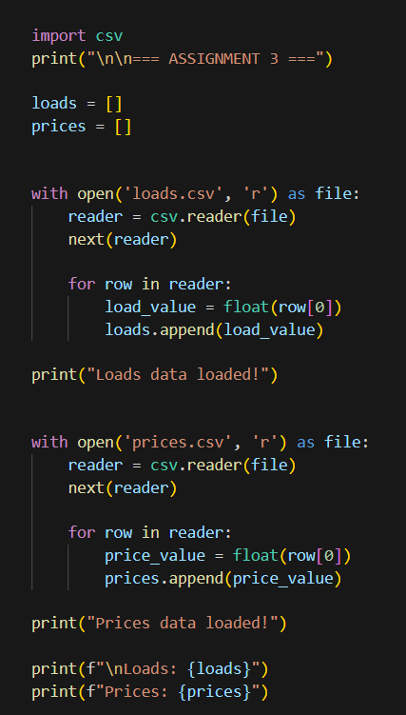

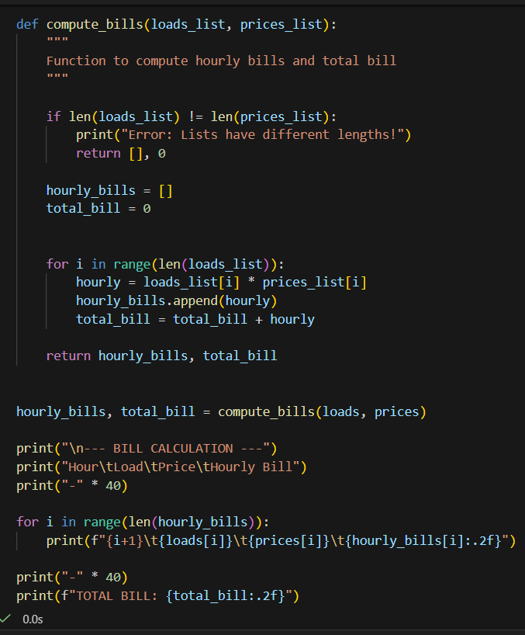
Output:
